
FREE flu vaccinations at participating pharmacies in H&F, RBKC and Westminster



Because of the work you do, you are entitled to a FREE flu vaccination. Take this slip to any pharmacy providing the London Flu Vaccination Service in the above boroughs to arrange your flu vaccination. They are available from 1st October 2026 – March 2027 but flu season is already here so the sooner the better! Please scan the QR code for further information!
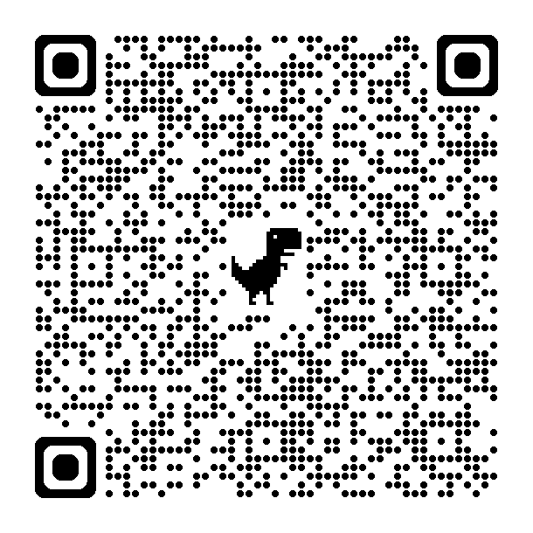

FREE flu vaccinations at participating pharmacies in H&F, RBKC and Westminster
Because of the work you do, you are entitled to a FREE flu vaccination. Take this slip to any pharmacy providing the London Flu Vaccination Service in the above boroughs to arrange your flu vaccination. They are available from 1st October 2026 – March 2027 but flu season is already here so the sooner the better! Please scan the QR code for further information!

FREE flu vaccinations at participating pharmacies in H&F, RBKC and Westminster
Because of the work you do, you are entitled to a FREE flu vaccination. Take this slip to any pharmacy providing the London Flu Vaccination Service in the above boroughs to arrange your flu vaccination. They are available from 1st October 2026 – March 2027 but flu season is already here so the sooner the better! Please scan the QR code for further information!

